REPLY FORM
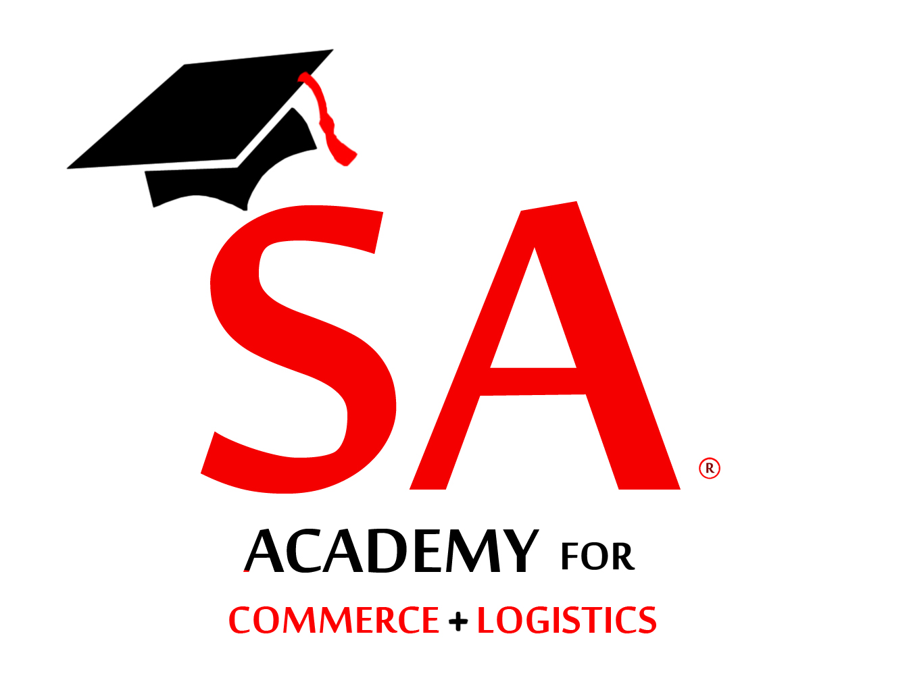
Forum on State of the Economy
Please send all applications preferably by email
Attn: Shippers’ Academy Colombo (Pvt) Ltd

ATTN: Secretary
Email: enquiries@shippersacademy.lk

Fax: +94112874065
Tele: 077-3820703-0113560844

Please reply on or before 23rd October 2017
Shippers’ Academy Colombo (Pvt) Ltd
105, Hunupitiya Lake Road
Colombo 02

Reference your circular dated 10th October 2017; we have the pleasure in nominating the following representatives to attend the forum on “State of the Economy with the Governor of CBSL” on the 24th October 2017 at Galadari Hotel, Colombo 1

NAME OF COMPANY :…………………………………………………………………………….

ADDRESS :……………………………………………………………………………..

TEL NOS :……………………………MOBILE:……………………………………..

FAX NO. :……………………E-MAIL………….……………………………………

NAME DESIGNATION Mobile E-mail

1)……………………………………………. ………………… …………………….. …………………..

2)……………………………………………….. ………………… ……………………. …………………..

3)……………………………………………….. ………………… ……………………. …………………..

4)……………………………………………….. ………………… ……………………. …………………..

5)……………………………………………….. ………………… ……………………. …………………..

Attached please find Cash/Cheque No:……………/ Bank ….….for Rs………………being participation fee at the above forum.
Cheques should be drawn in favour of “Shippers’ Academy Colombo (Pvt) Ltd” (Rs. 2, 800/- per participant) Fee to be paid prior to the event.

Authorised by:…………………………………….. Signature………………………..

Designation:……….…………………… Date:…………………………….

